**TASK 14:**

**Web deployment the web application developed in ASP.NET.**

Web deployment is the process of moving a web application from a development environment to a live server so it can be accessed by users over the internet

**Steps for web deployment using Web Server (IIS):**

1. Solution Explorer, right-click your project and choose **Publish**.

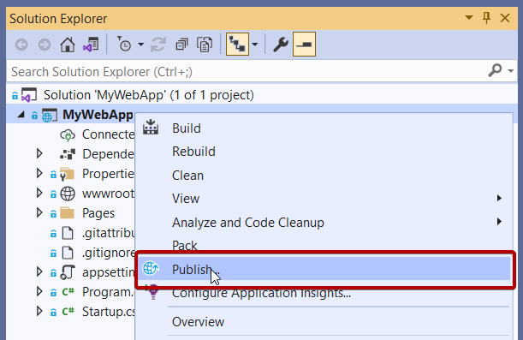

If you're publishing this web app for the first time, next you see the Publish wizard.

**Choose the option for publishing:**

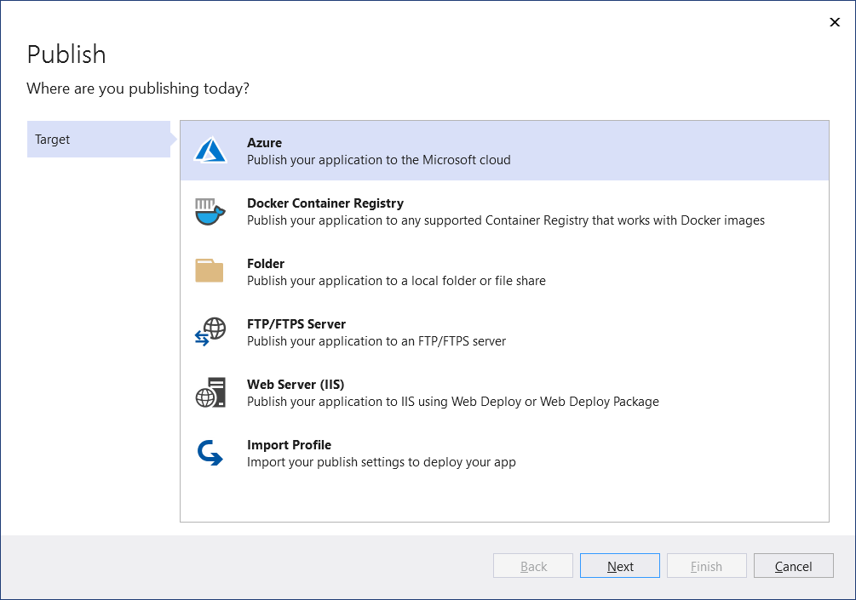

**Steps for Web Server (IIS)**

Choose **Publish**, and then **Web Server (IIS)**.

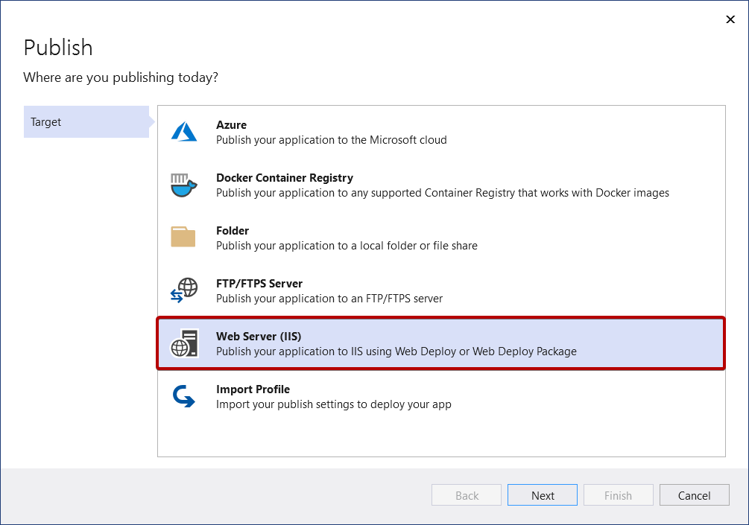

Pick the desired deployment mode. Choose Web Deploy to immediately deploy the application to the specified server. Choose Web Deploy Package to create a packaged zip file that contains the deployment artifacts for later use by you or someone else.

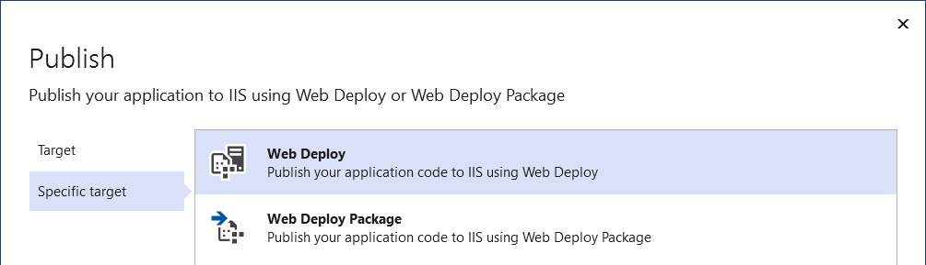

### Web Deploy

Provide the necessary connection details and choose **Finish**.

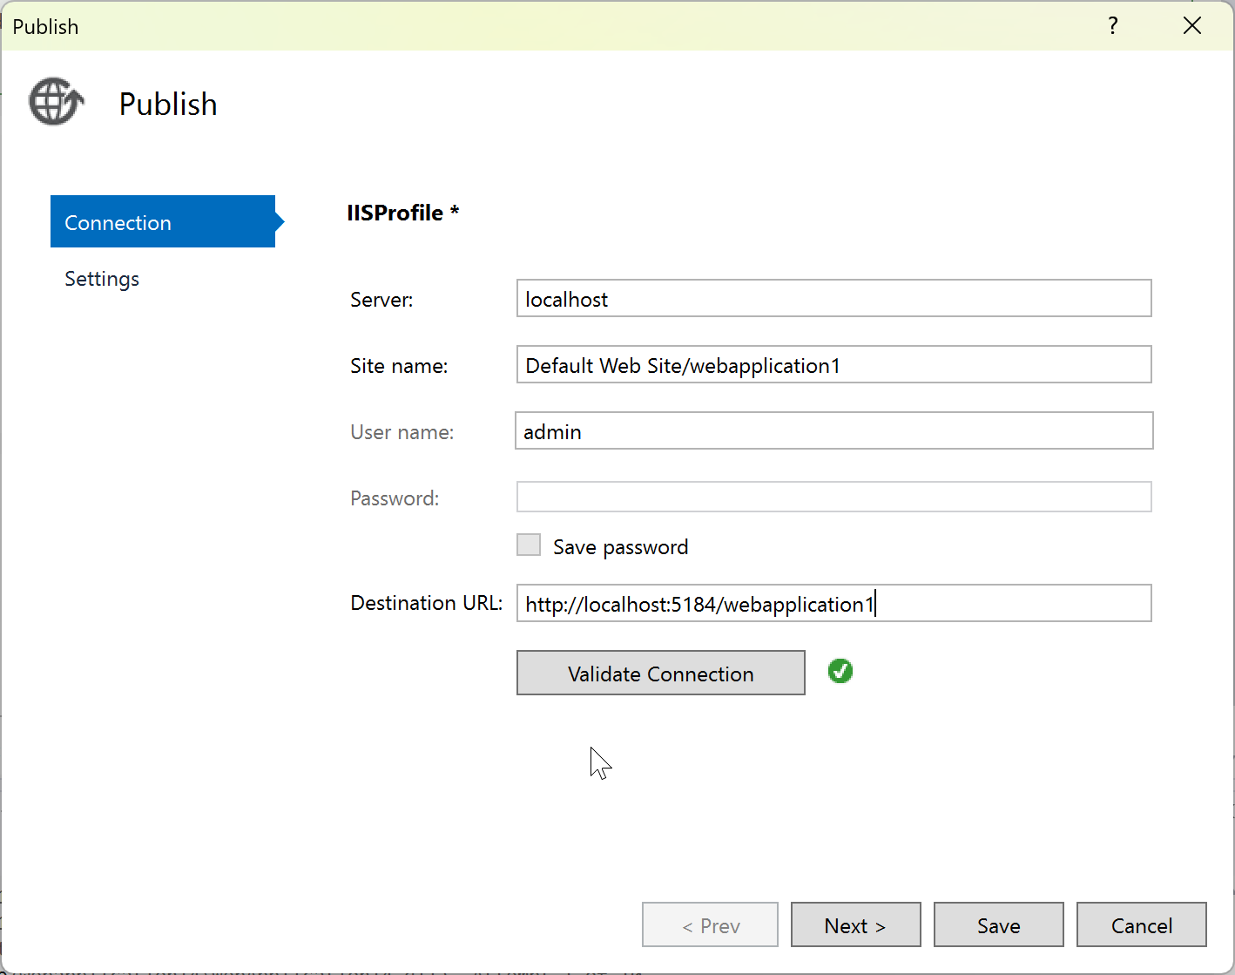

The first time you publish, create a username and password. These credentials are specific to WebDeploy deployment.

### Finish the Publish wizard

Next, you see the summary page for the new [publish profile](https://learn.microsoft.com/en-us/visualstudio/deployment/publish-overview?view=vs-2022) that you just created using the Publish wizard. Click **Publish** and Visual Studio deploys your web app to the specified IIS server.

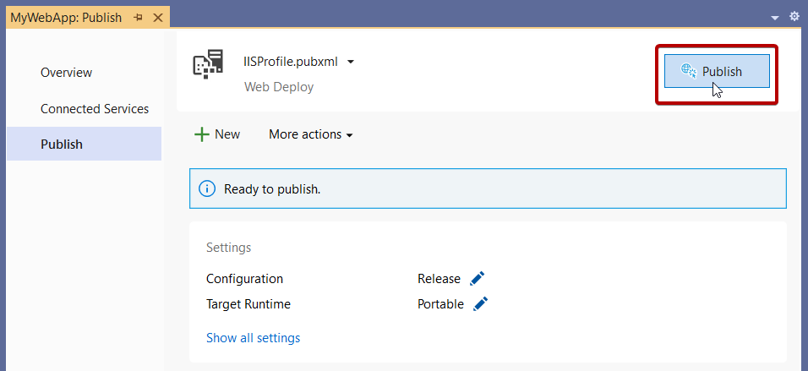

**You can publish your web app to IIS if IIS is configured.**